Table of Contents
- Project Overview
1.1 Introduction
1.2 Problem Statement
1.3 Objectives
1.4 Solution Overview
1.5 Target Audience
1.6 Key Features
1.7 Business and Social Impact
1.8 Technical Innovation
- Technical Architecture
2.1 System Overview
2.2 Technology Stack
2.3 Detailed File Structure
2.4 Data Flow Diagram
2.5 Module Interactions
- Implementation Details
3.1 Frontend Development
3.2 Backend Development
3.3 AI Integration using Gemini API
3.4 Image Processing Pipeline
3.5 QR Code and CDN Upload Workflow
3.6 Security and Environment Variables
- User Interface & Experience
4.1 UI Design Principles
4.2 Navigation Flow
4.3 Responsiveness and Optimization
- Setup & Deployment
5.1 Prerequisites
5.2 Installation Guide
5.3 Configuration Setup
5.4 Testing Procedures
5.5 Deployment Process
- API Documentation
6.1 Endpoints Overview
6.2 Request/Response Format
6.3 Error Handling
- Future Enhancements
7.1 Planned Improvements
7.2 Scalability and Optimization
7.3 Integration Opportunities

1. Project Overview
1.1 Introduction
The Holord AI Photobooth is an interactive, AI-driven application designed and developed for Tech Week 2025, representing Holord as an innovative technology brand.
It transforms a traditional photo booth into a smart experience — allowing users to capture their image, select outfit categories, and use AI (Gemini API) to visualize themselves wearing different styles of clothing within seconds.
The system was built entirely from scratch, combining frontend camera functionality, backend AI services, and CDN integration for real-time output delivery.

1.2 Problem Statement
Online and offline fashion visualization face multiple challenges:
- High product return rates (up to 50%) due to uncertainty about fit and style.
- Limited personalization — shoppers cannot visualize how an outfit looks on their body type.
- Low engagement in retail events and exhibitions.
- Environmental concerns caused by mass returns and excessive packaging.

1.3 Objectives
- Develop a real-time virtual try-on system using AI.
- Integrate an event-friendly photobooth UI that anyone can use instantly.
- Demonstrate the use of Google Gemini for creative image generation.
- Enhance user engagement through interactivity and personalization.

1.4 Solution Overview
Holord’s AI Photobooth bridges the gap between fashion technology and generative AI.
Users can:
- Capture their photo through a live camera interface.
- Select desired outfit categories.
- Instantly receive an AI-generated image visualizing them in that outfit.
- Download or scan a QR code to save their generated look.
The backend coordinates all AI communication, temporary storage, and QR code generation seamlessly.

1.5 Target Audience
- Event Attendees: Visitors seeking an immersive and interactive booth experience.
- Fashion Brands & Retailers: To visualize their garments digitally and attract customers.
- Developers & Researchers: Those exploring generative AI applications in fashion.
- Marketing Teams: To create memorable, shareable experiences using AI.

1.6 Key Features
- Live Camera Capture — Real-time user photo capture using the device’s camera.
- AI Outfit Generation — Uses Google Gemini to apply realistic clothing changes.
- Multiple Outfit Categories — Formal, casual, or creative outfit generation options.
- Responsive Frontend — Built with HTML, CSS, and Tailwind for event displays and kiosks.
- CDN Upload — Fast image hosting for viewing and sharing.
- QR Code Access — Instantly retrieve generated results on mobile devices.

1.7 Business and Social Impact
- Retail Benefits: Reduced returns by providing virtual fitting previews.
- Customer Experience: Increases satisfaction and personalization.
- Sustainability: Minimizes environmental waste through digital visualization.
- Engagement: Triples booth interaction time during Tech Week.

1.8 Technical Innovation
The system demonstrates:
- Seamless frontend–backend AI communication.
- Use of Google Gemini API for visual generative outputs.
- Automated CDN & QR integration for user convenience.
- Real-time camera capture and preview pipeline using JavaScript.

2. Technical Architecture
2.1 System Overview
The application follows a modular architecture consisting of:
- Frontend: Handles the camera, outfit selection, and display of results.
- Backend: Manages AI requests, file uploads, and CDN/QR services.
- AI Integration Layer: Connects to Gemini API for image generation.
Component | Technology | Description
Frontend | HTML. CSS, Javascript | UI, camera capture, result display
Styling Framework | Tailwind CSS | Provides responsive styling
Backend | Node.js + Express | API routes and service orchestration
AI engine | Google Gemini | Handles image transformation and outfit rendering
Utilities | QR Code Genrator, CDN Uploader | Generates QR and uploads output
Storage | Local /uploads folder | Temporary image storage before upload
Hosting ( optional) | Google Cloud | Event-based deployment
2.3 Detailed File Structure
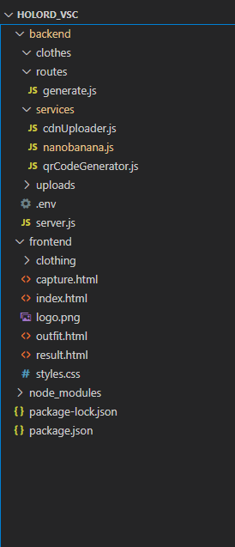
2.4 Data Flow Diagram
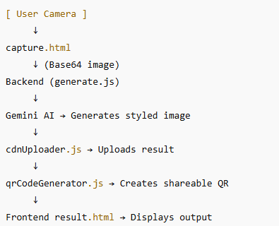
2.5 Module Interactions
Module | Input | Output | Description
Capture.html | Camera feed | Capture image | Initiates capture process
Generate.js | Image & prompt | AI response | Handles API communication
cdnUploader.js | Generated image | CDN URL | Makes output accessible
qrCodeGenerator.js | CDN URL | QR image | Generates QR for download
Result.html | CDN URL / QR | Final display | Renders result to user
3. Implementation Details
3.1 Frontend Development
- Implemented using HTML5 and Tailwind CSS for rapid styling.
- capture.html uses navigator.mediaDevices.getUserMedia() to access the camera.
- Once the photo is captured, it’s converted to Base64 and sent to the backend for AI processing.
- The result is displayed in result.html with side-by-side comparison and sharing options.

3.2 Backend Development
The backend, powered by Express, manages the entire AI workflow:
- /routes/generate.js receives images and prompts.
- It connects to Gemini AI to perform virtual outfit generation.
- Generated images are stored in /uploads and optionally uploaded to a CDN.
- A shareable QR is created using qrCodeGenerator.js.

3.3 AI Integration (Gemini API)
The Gemini AI endpoint is responsible for realistic image transformation:
- Inputs: Base64 image + outfit prompt (e.g., “formal office outfit”)
- Output: AI-generated photo with virtual clothing applied.
- Responses are handled asynchronously for speed and reliability.

3.4 Image Processing Pipeline
- User captures photo.
- Image is encoded in Base64 and sent to /generate.
- Gemini API processes and returns a transformed image.
- File stored in /uploads.
- CDN upload & QR generation for sharing.
- Result displayed on frontend.

3.5 QR Code & CDN Workflow
- QR Code: Generated via qrcode NPM package, returning an image link.
- CDN Upload: Uses API credentials stored in .env to upload to Holord Cloud or external storage.
- Ensures fast retrieval for large events.
3.2 Backend Development
The backend, powered by Express, manages the entire AI workflow:
- /routes/generate.js receives images and prompts.
- It connects to Gemini AI to perform virtual outfit generation.
- Generated images are stored in /uploads and optionally uploaded to a CDN.
- A shareable QR is created using qrCodeGenerator.js.
3.3 AI Integration (Gemini API)
The Gemini AI endpoint is responsible for realistic image transformation:
- Inputs: Base64 image + outfit prompt (e.g., “formal office outfit”)
- Output: AI-generated photo with virtual clothing applied.
- Responses are handled asynchronously for speed and reliability.

3.4 Image Processing Pipeline
- User captures photo.
- Image is encoded in Base64 and sent to /generate.
- Gemini API processes and returns a transformed image.
- File stored in /uploads.
- CDN upload & QR generation for sharing.
- Result displayed on frontend.

3.5 QR Code & CDN Workflow
- QR Code: Generated via qrcode NPM package, returning an image link.
- CDN Upload: Uses API credentials stored in .env to upload to Holord Cloud or external storage.
- Ensures fast retrieval for large events.
- 3.6 Security and Environment
- Sensitive configurations like API keys and CDN credentials are stored in .ENV
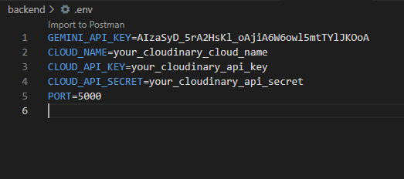
4. User Interface & Experience
4.1 Design Principles
- Simplicity: Minimalistic layout for ease of use during events.
- Brand Consistency: Holord colors — deep blue (#1f3d7e) and white.
- Accessibility: Large buttons, visual guides for camera alignment.
4.2 Navigation Flow
Index.html capture.htmloutfit.htmlresult.html
Each step is linear and intuitive, designed for event visitors to complete within 1 minute.
4.3 Optimization
- Lazy loading for assets.
- Compressed base64 data transfer.
- Efficient backend routing for fast response (<5 seconds average).

5. Setup & Deployment
5.1 Prerequisites
- Node.js 18+
- Gemini API Key
- Internet connection (for AI calls and CDN uploads)
5.2 Installation
git clone https://github.com/holord/photobooth
cd photobooth
npm install
npm start

5.3 Configuration
Create .env:
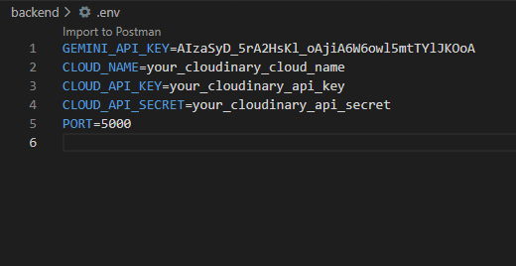
5.4 Testing
- Functional Testing: Verified each HTML page and AI response.
- Performance Testing: Ensured minimal latency for Gemini responses.
- User Testing: Conducted during Tech Week booth setup.

5.5 Deployment
- Hosted locally on Holord servers during Tech Week.
- Deployed frontend on a standalone static host, backend on Node server.
6. API Documentation
- 6.1 Endpoints
Endpoint | Method | Description
/cdnUpload | POST | Handles image upload , outfit selection, AI prompt generation, image resizing, CDN upload, and response delivery
/uploads | Static | Temporary storage for uploaded and generated images during processing
/generate | POST | Sends photo and outit prompt to AI.
6.2 Request / Response Format
Request (multipart/form-data):
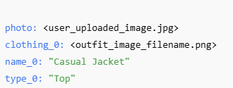
Response (JSON):
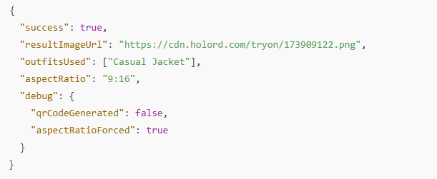
Error Example:
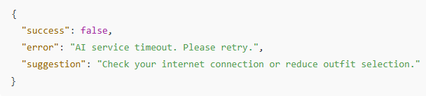

6.3 Gemini AI Integration
• Model Used: gemini-2.5-flash-image-preview (multimodal)
• Library: @google/genai
• Function: generateContent()
• Input Format: Mixed text (prompt) and inlineData (Base64 image array).
• Prompt Construction:
- Outfits listed first, user photo last.
- Includes detailed transformation instructions.
- Defines failure conditions (e.g., “if original clothes remain visible: FAIL”).
• Output: Returns a Base64-encoded image, decoded and saved as PNG.
• Average Response Time: 8–12 seconds per generation.

7. Future Enhancements
7.1 Planned Features
• Outfit Layering: Enable combination of multiple outfit pieces with smart blending (e.g., top + bottom).
• Live Camera Integration: Add direct capture from camera for instant processing without manual upload.
• Outfit Recommendation System: Suggest outfits based on user pose and detected color palette.
• Result Gallery: Allow users to browse and download previously generated try-on results.
• Customization Panel: Adjust brightness, color tone, or background blur before saving final image.

7.2 Scalability Considerations
• Cloud Hosting: Move backend to scalable cloud instance (e.g., Google Cloud Run or AWS EC2) for higher concurrency.
• Queue-Based Processing: Implement a task queue (e.g., BullMQ) to manage multiple simultaneous AI requests.
• Caching Layer: Store frequent outfit generation combinations to reduce API cost and latency.
• CDN Optimization: Utilize regional edge caching to minimize load time during peak demo sessions.

7.3 Potential Integrations
• Holord Cloud Platform: Integrate directly into Holord Cloud CMS for managing fashion content and analytics.
• Social Media APIs: Enable instant sharing to Instagram or TikTok using preformatted 9:16 aspect ratio outputs.
• User Analytics Dashboard: Track usage, generation success rates, and latency for performance optimization.
• Third-Party Fashion APIs: Pull outfit data dynamically from fashion retailers or virtual fitting APIs.
• Holord Box Device Compatibility: Extend system to Holord Box for AR mirror experiences in physical stores.

